Procedure for linking affected equipment to a COMPULSORY Service Bulletin
In edit mode, add lines to the “SN ranges covered” to describe ranges of equipment specified by serial number and model.
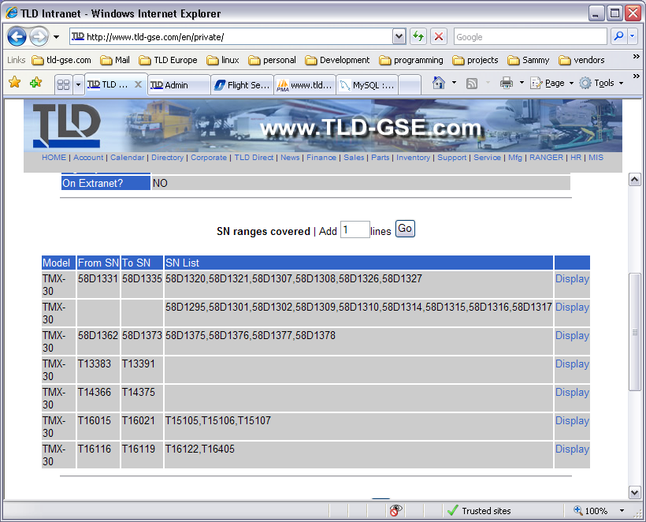
Once complete, hit the Back to module link.
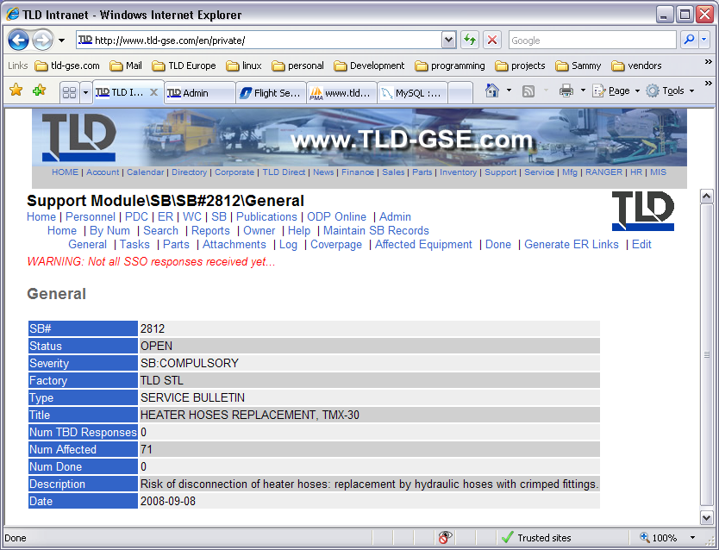
Hit the Generate ER Links menu item.
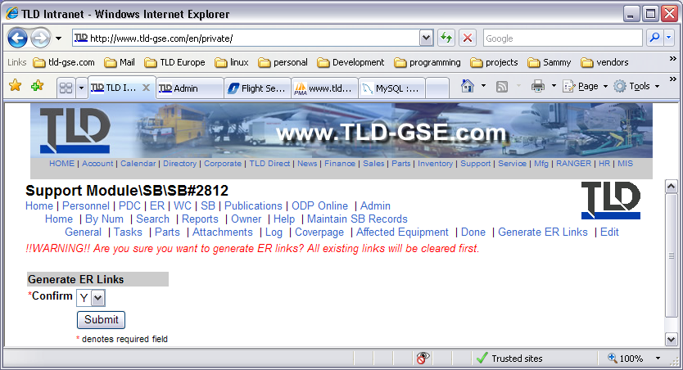

Select Y to confirm that you want to proceed.

Make sure that you want to do this as the existing list will be deleted before the new list is generated.

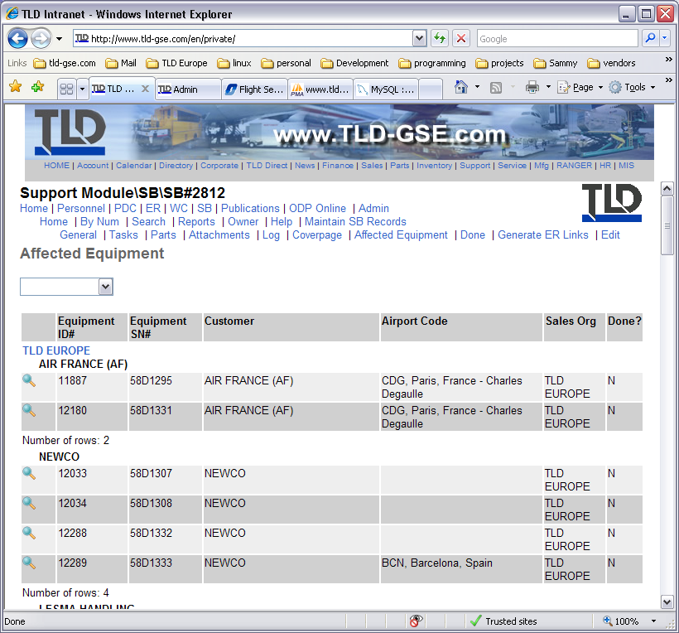

The new list is shown after all the links have been made.

